

**Hard Drives**



**Name: ORICO 2139U3 Transparent 2.5 inch HDD Case**

**Price:** Rs. 995

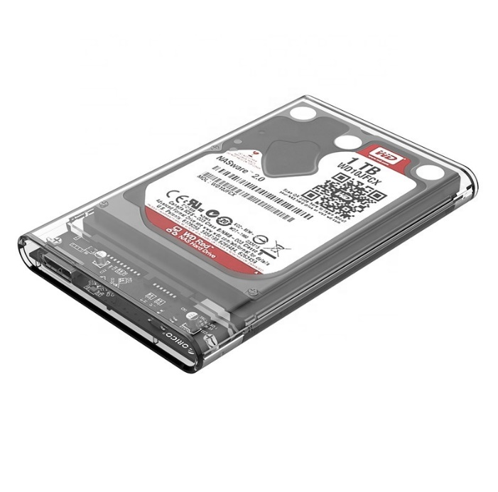**Product details of ORICO 2139U3 Transparent 2.5 inch HDD Case**

* usb 3.0 HDD enclosure
* High write/read speed
* windows/mac/Linux supported
* ORICO 2139U3 Transparent 2.5 inch HDD Case

**Specifications of ORICO 2139U3 Transparent 2.5 inch HDD Case**

* Brand

Orico

* SKU

109296167_PK-1259386129

* Model

2193 u3